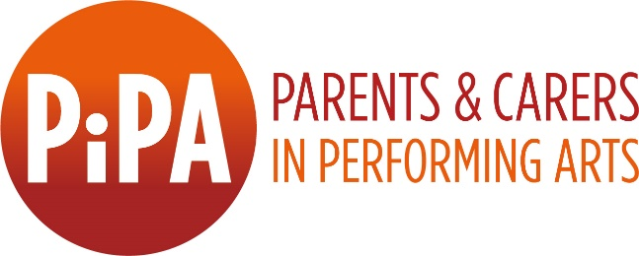

PiPA Scotland Manager

  - Job Description
Hours: 21 hours per week, remote/ home-working, flexible
Remuneration: £30,000 pro-rata
Contract: 10 month Fixed Term Contract (with potential to become permanent), PAYE
Start date: Mid November 2021
Reporting to: PiPA CEO Anna Ehnold-Danailov
Application Deadline: 9am Tuesday 26th October
Zoom Interview Dates: w/c 8th and w/c 15th November

About the Role
Parents and Carers in Performing Arts (PiPA) seeks a Programme Manager to take a prominent role in supporting the Charity, contributing to its strategic direction and delivering our programme and supporting events in Scotland in partnership with Federation of Scottish Theatre and funded by Creative Scotland.
Building on our existing network in Scotland, this role will lead on strategic business and operational development for PiPA’s work in Scotland, developing new relationships and strengthening existing partnerships. The goal of this project is to establish PiPA as a support organisation for the Scottish performing arts sector and to increase the engagement in the PiPA Charter Programme across the region.
You will take a major role in shaping the future direction of the work needed to support the Scottish performing arts network and wider creative community on its way to becoming more family friendly. Key areas of focus include implementing and progressing the development of a new PiPA pilot programme, recruiting and supporting organisations to participate, capturing their learning and key trends and shaping the future rollout of the programme. You will also be instrumental in generating new revenues and seeking funding opportunities that can help support PiPA’s work in Scotland to ensure the continuation and sustainability of PiPA Scotland beyond the initial 10 months.
In return we proactively promote work-life balance, offer 25 days annual leave plus public/bank holidays (pro-rated to hours worked) and provide a high degree of flexibility and autonomy in the role.

This is an excellent opportunity to join a small, ambitious, and committed team within a supportive and flexible working environment to make a real difference for parents and carers working in the Scottish performing arts sector. Although this role is conducted remotely, the PiPA Scotland Manager must be Scotland-based. This Scotland project will intersect with PiPA’s current research projects investigating how protected characteristics intersect with caring responsibilities, and the challenges faced by parents and carers in Music and Dance. We are particularly keen on hearing from applicants with protected characteristics and/or a music, dance or opera background.

Areas of responsibility
- Partnership development and management:
  - Promote PiPA’s work in Scotland.
  - Building partnerships and collaborations with Scottish funders, performing arts support organisations and Government, proactively identifying opportunities for collaboration.
  - Recruitment and development of new Charter Partners from within the Music, Theatre, Dance and Opera sectors in Scotland, of all scales and remits.

- Project management and evaluation:
- Implementing and overseeing the new PiPA pilot programme.
- Coordinate and deliver workshops, seminars, or other relevant activities to deepen organisations’ understanding of strategies to support parents and carers.
- Monitor and evaluate the impact of the pilot programme, working with the PiPA team to refine and embed improvements within the framework.
- Delivery of case studies and final project report.

- Funding
  - Securing long-term financial and strategic partnerships with performing arts organisations, membership organisations and funders who share our values and would like to support the Scottish performing arts sector to become a more family friendly employer.
  - Identify potential trusts and foundations to support the long-term sustainability of PiPA’s work in Scotland, supporting as required.

PiPA Scotland Manager Person Specification:
We are particularly interested in hearing from applicants who have the following skills and experience:
- 5+ years' experience of project management and delivery
- Proven experience of new business and pipeline development, including researching, identifying and targeting potential partners and funders
- Significant experience in stakeholder management at all levels
- Experience of monitoring and evaluating impact, and the ability to report against project targets.
- Ability to define project objectives and deliver against KPI’s
- Excellent communication skills, both written and verbal, with stakeholders at all levels
- Experience of successful fundraising and income generation
- Passionate and proactive about diversity, equality and inclusion

The following would also enhance an application:
- Experience leading on organisational change and its HR implications
- Understanding of the challenges faced by parent and carers in the performing arts
- Problem-solving ability
- Ability to identify opportunities for growth and change
- Ability to use data driven insights for improvement and progression
- A background in music or dance sector
- Interest in and understanding of the Scottish performing arts industry and its working practices.

Application:
PiPA welcomes applications from everyone regardless of their age, sex, race, religion or belief, sexual orientation, gender identity, ethnicity, disability or nationality. We respect and value what everyone can bring to PiPA. Diversity of experience, thought and voice adds immeasurable strength to our team, so we will take these factors into account when making appointment decisions.
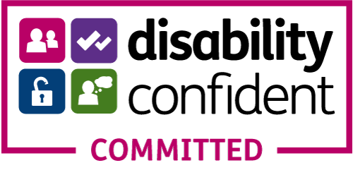
We are keen to hear from people from underrepresented groups in the performing arts (including people who are Black, Asian, Dual Heritage or from an Ethnically diverse background; D/deaf & Disabled people; people who are from lower socio-economic backgrounds; and/or people with caring responsibilities, or any other under-represented backgrounds in the performing arts sector.)
PiPA is a Disability-Confident Employer.

PiPA is committed to attracting, supporting, and retaining a more diverse and flexible workforce. Our application materials are available in a range of accessible formats, and we accept audio and/or video applications as well as written. If you require application materials in alternative format, please don’t hesitate to contact bryony@pipacampaign.com.
PiPA enables and empowers parents and carers. We are always happy to discuss solutions that allow people to balance their caring responsibilities with their working lives, for example through job shares or flexible working arrangements.

To apply for this position please submit the following to recruitment@pipacampaign.com:
- Completed Application form.
- Completed Monitoring form.
- A video, audio or written statement outlining your relevant experience to date which will enable you to deliver the areas within this role, and why you would like to work with PiPA. Written statement should be no more than 2 pages, and video/audio responses no longer than 5 minutes. A strong application will directly address how your experience to date matches the points within the ‘Required Experience and Desirable Skills’ section.
- An up to date CV.

About PiPA:

Parents and Carers in Performing Arts (PiPA) believes a truly world class performing arts is inclusive of all talent and circumstances. We work together to amplify the voices of parents and carers across all the performing arts. We encourage a new mindset, that parents and carers enrich our industries. We show what’s possible.
PiPA works collaboratively with the performing arts industry to develop and implement strategies for change and promote best practice employment. PiPA’s pioneering Charter Programme supports performing arts organisations to implement effective strategies to ensure that they are able to attract and retain a diverse and flexible workforce inclusive of carers and parents.
Underpinned by rigorous research, PIPA aims to shift mindsets, address disadvantages, lobby for change and map out practical ways forward. Since PiPA’s formation, leaders across the arts have responded rapidly and with enthusiasm to new ideas, integrating PiPA into new working structures and approaches. In 2020 PiPA became a registered charity and has ambitious plans for future growth. Recent projects include a successful pilot project in Scotland, an in-depth analysis of COVID’s impact on performing arts, and the preliminary work for expansions into Music and Dance.

